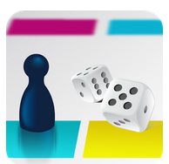
Make & Play Quiz
(Free App)

Published on iTunes:
https://itunes.apple.com/us/app/makeandplayquiz/id1266720190?ls=1&mt=8
or http://tinyurl.com/y9rjtbxg

Published on Google Play at: https://play.google.com/store/apps/details?id=com.kihdapps.ttac_game or http://tinyurl.com/jj9x8vl
Make & Play Quiz allows teachers to design their own unique board game or "quiz", where students can learn or strengthen their skills by playing a game. Each square can have a Question (Multiple Choice, Fill in the Blank or True/False) or an Event (Stop-skip turns, Go forward, Go Back or Get Points). One to four players can play at a time and the games can be shared with others.
