GMU/CEHD/KIHD/TTAC Apps (1/2018)
Published on iTunes
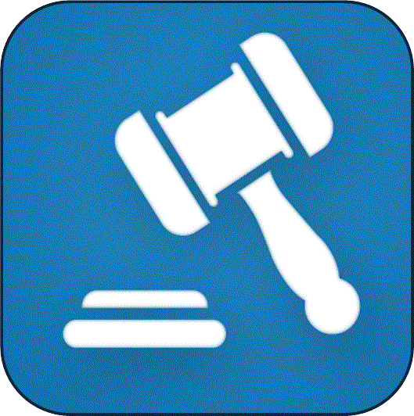 This App renders the "Parent’s Guide to Special Education Dispute Resolution" by the Virginia Department of Education (VDOE), for mobile devices. It covers "Mediation," "Formal Complaint," and "Due Process" and includes a section that defines relevant "Acronyms" and a "Glossary." The application offers an easy to use question and answer format. Many answers include a direct link to the Regulations Governing Special Education Programs for Children with Disabilities in Virginia. It is designed to help parents and educators better understand their rights and responsibilities during the dispute resolution process. (Oct. 2014) This free Parent’s Guide to Special Education Dispute Resolution App is on iTunes or http://tinyurl.com/hydqkff.

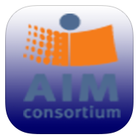The AIM Explorer is a free simulation that combines grade-leveled digital text with access features common to most text readers and other supported reading software. Magnification, custom text and background colors, text-to-speech, text highlighting, and layout options are presented in a logical sequence to help struggling readers decide which of these supports might help them to access and understand text. The AIM Explorer is designed to be used by a reader working collaboratively with an educator, tutor, parent, or assistive technology specialist as a guide. AIM Explorer v.1.0 is an iPad version of the Adobe-Air based AIM Explorer developed at National Center on Access Educational Materials at CAST, Inc. (http://aem.cast.org/). (Oct. 2016) This free Aim Explorer App is posted on iTunes or http://tinyurl.com/heo43q3.

The AIM-VA Navigator App facilitates the process that guides the decisions of a collaborative team as they work through the AIM-related needs of individual students. It is not a screening or diagnostic tool. The Navigator consists of a series of questions to assist teams with decision-making about need, selection, acquisition, and use of accessible instructional materials. Learning supports for completing each decision-making step are available throughout. The AIM Navigator App collects the decisions made along with any notes entered into text boxes at each point. All are included in a summary that can be viewed at any time, saved, sent, or printed. (Apr. 2016) This free AIM-VA Navigator App is on iTunes or http://tinyurl.com/zn8uns9.

AT Consideration Guide App: IDEA (1997) added the requirement that each IEP team consider the need for assistive technology as part of the Consideration of Special Factors. IEP teams must also document their consideration of assistive technology in the IEP plan. The consideration guide is to assist school divisions in developing a process for consideration of AT in the IEP process. (Apr. 2016) This free AT Consideration Guide App is on iTunes or http://tinyurl.com/zjy5omz.

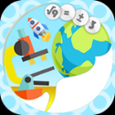 The Brain Injury Strategies App (currently available for iPad only) is intended to provide ideas for supporting an individual who is returning to learning. It addresses various areas of concern that can happen after a concussion, a type of traumatic brain injury. The end product is a summary of selected strategies that can be implemented by an educator for an individual student. (June 2016, updated July 2016) This free Brain Injury App is on iTunes or http://tinyurl.com/jcocem4.

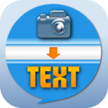 EZPic2Txt App: This texting app provides a picture-based system for individuals with disabilities, who are non-readers or who are not able to text using a standard touch screen keyboard. The user can send important preset message(s) (created by a family member or supervisor) to necessary preset contact(s) as email messages or text messages with one swipe or touch. Users can also receive messages sent to them by others using this app. Messages sent or received by the user can be read out loud using text-to-speech technology. (Feb. 2017) This free EZPic2Txt App is on iTunes or http://tinyurl.com/z7oohn6.

NEW- MakeAndPlayQuiz allows teachers to design their own unique board game or "quiz", where students can learn or strengthen their skills by playing a game. Each square can have a Question (Multiple Choice, Fill in the Blank or True/False) or an Event (Stop-skip turns, Go forward, Go Back or Get Points). One to four players can play at a time and the games can be shared with others. (Aug. 2017) This free MakeAndPlayQuiz app is on iTunes or http://tinyurl.com/y9rjtbxg.

Published on Google Play
This App renders the "Parent’s Guide to Special Education Dispute Resolution" by the Virginia Department of Education (VDOE), for mobile devices. It covers "Mediation," "Formal Complaint," and "Due Process" and includes a section that defines relevant "Acronyms" and a "Glossary." The application offers an easy to use question and answer format. Many answers include a direct link to the Regulations Governing Special Education Programs for Children with Disabilities in Virginia. It is designed to help parents and educators better understand their rights and responsibilities during the dispute resolution process. (Apr. 2016) This free SE Resolution App is on Google Play or http://tinyurl.com/hmetgy8.

NEW- The AIM Explorer is a free simulation that combines grade-leveled digital text with access features common to most text readers and other supported reading software. Magnification, custom text and background colors, text-to-speech, text highlighting, and layout options are presented in a logical sequence to help struggling readers decide which of these supports might help them to access and understand text. The AIM Explorer is designed to be used by a reader working collaboratively with an educator, tutor, parent, or assistive technology specialist as a guide. AIM Explorer v.1.0 is an iPad version of the Adobe-Air based AIM Explorer developed at National Center on Access Educational Materials at CAST, Inc. (http://aem.cast.org/). This free AIM Explorer App is published on Google Play or http://tinyurl.com/y7pykyyo.

This AIM-VA Navigator App facilitates the process that guides the decisions of a collaborative team as they work through the AIM-related needs of individual students. It is not a screening or diagnostic tool. The Navigator consists of a series of questions to assist teams with decision-making about need, selection, acquisition, and use of accessible instructional materials. Learning supports for completing each decision-making step are available throughout. The AIM Navigator App collects the decisions made along with any notes entered into text boxes at each point. All are included in a summary that can be viewed at any time, saved, sent, or printed. (Apr. 2016) This free AIM-VA Navigator App is on Google Play or http://tinyurl.com/zsff9h5.

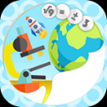 The Brain Injury Strategies App (Works best on an Android tablet) is intended to provide ideas for supporting an individual who is returning to learning. It addresses various areas of concern that can happen after a concussion, a type of traumatic brain injury. The end product is a summary of selected strategies that can be implemented by an educator for an individual student. (Mar. 2017) This free Brain Injury App is on Google Play or http://tinyurl.com/hfph6he.
.
Make & Play Quiz allows teachers to design their own unique board game or "quiz", where students can learn or strengthen their skills by playing a game. Each square can have a Question (Multiple Choice, Fill in the Blank or True/False) or an Event (Stop-skip turns, Go forward, Go Back or Get Points). One to four players can play at a time and the games can be shared with others. (Aug. 2016) This free Make & Play Quiz App is on Google Play or http://tinyurl.com/jj9x8vl.

