**Instructional Activity Resources for 3M-NSCE 1**

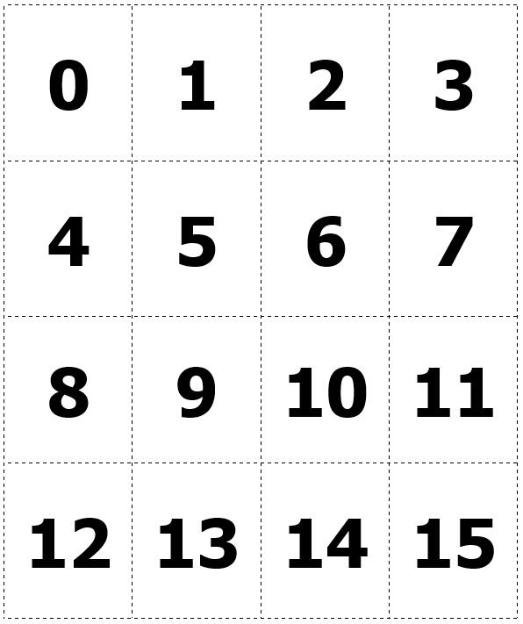

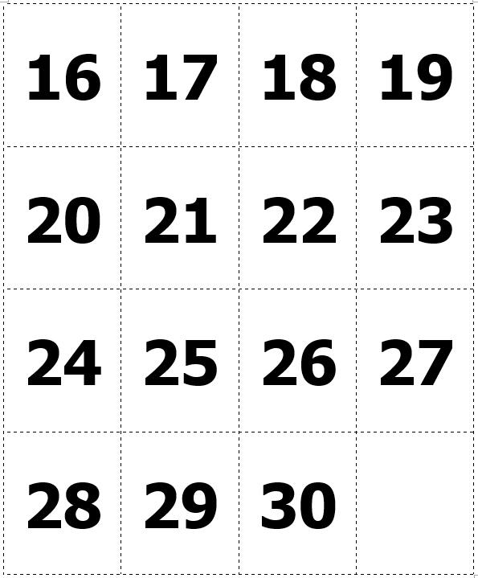

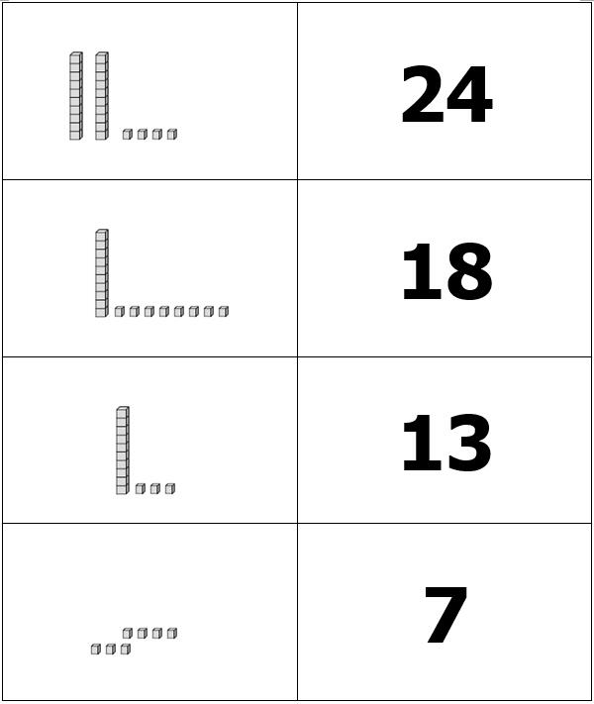

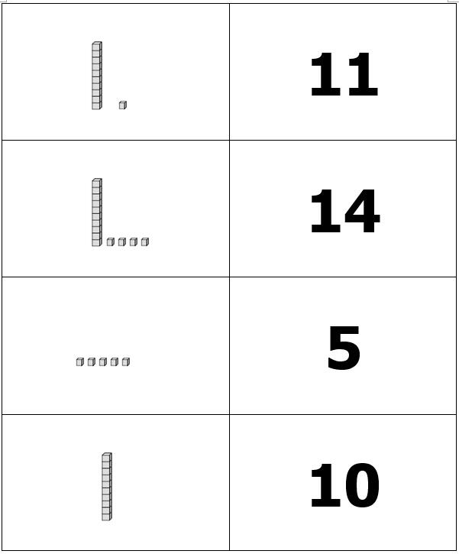

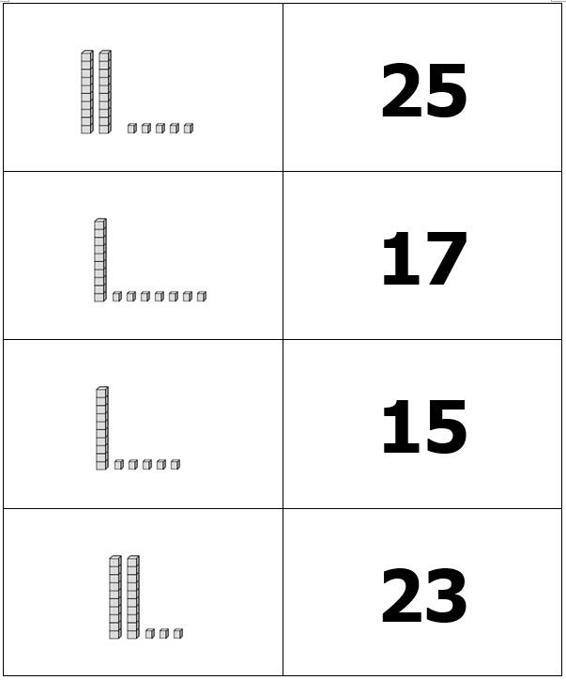

**Instructional Activity Resources for 3M-NSCE 2**

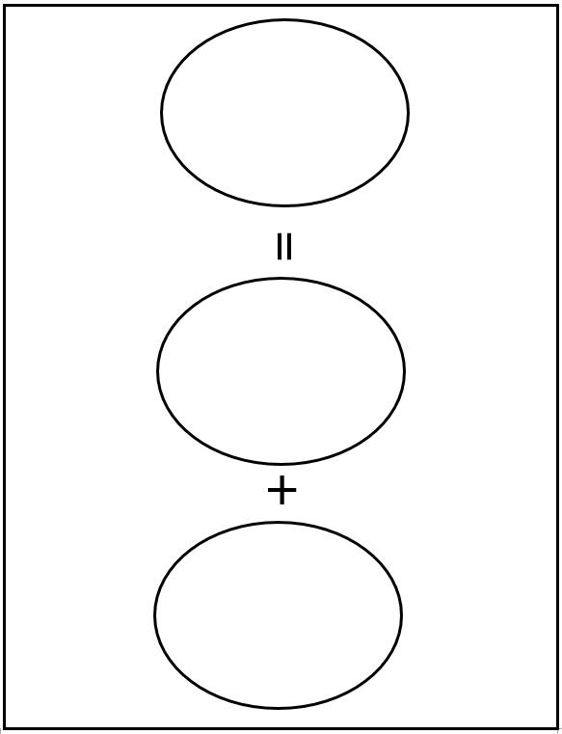

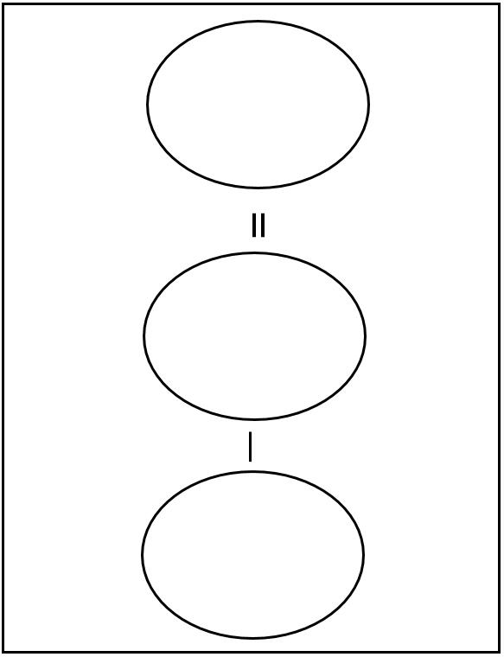

**Instructional Activity Resources for 3M-MG 4**

printable models and pictures of plane geometric figures: 
1. rectangle- one half is shaded.
2. circle- one half is shaded.
3. rectangle- one third is shaded.
4. circle- one third is shaded.
5. rectangle- one fourth is shaded.
6. circle- one fourth is shaded

printable pictures of different sized geometric figures: 
1. A rectangle
2. A rectangle
3. A rectangle
4. A circle
5. A circle
6. A circle


printable pictures of different sized geometric figures: 
1. A triangle
2. A triangle
3. A triangle
4. A sqaure
5. A sqaure
6. A sqaure

printable pictures of different sized geometric figures: 
1. A cube
2. A cube
3. A rectangular prism
4. A rectangular prism
5. A rectangular prism
6. A cylinder

printable pictures of different sized geometric figures: 
1. A cylinder
2. A cylinder
3. A cone
4. A cone
5. A pyramid 
6. A pyramid 

printable pictures of different sized geometric figures: 
1. A sphere with radius r
2. A sphere with radius r
