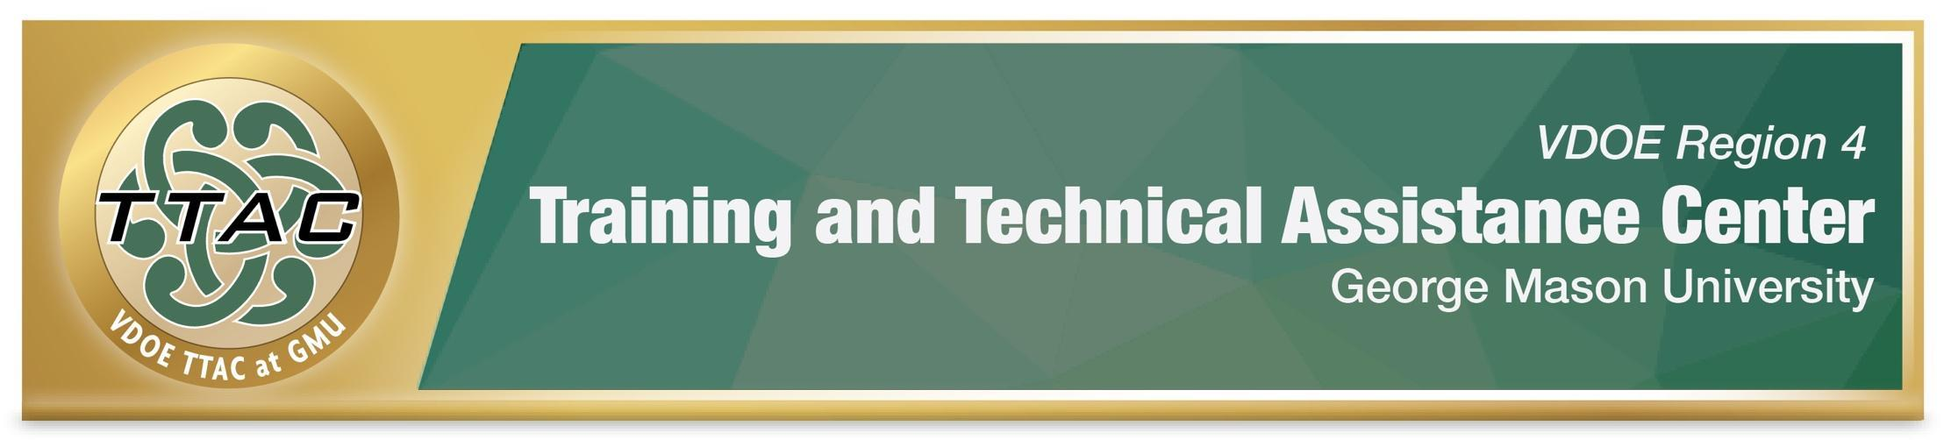
Flexible Grouping Considerations
Type of Flexible Group | When to Use | Considerations
Whole Class  The entire class works as a group together | When students have similar skills, strengths and needs related to the most important skills in the learning objective.  For example: The entire class needs to review and practice how to find the common denominator before learning to add rational algebraic expressions. | More difficult to differentiate  Fewer opportunities for individualized practice with frequent teacher feedback.
Heterogeneous Groups  Students with different skill levels work together.  Types:  Peer Assisted Learning Strategies (PALS) in Reading  - PALS K-1  - PALS 2-6  - PALS High School  Peer Assisted Learning Strategies (PALS) in Math  Peer Tutoring  - Cross Age Peer Tutoring in Math & Reading  - Math Wise Peer Tutoring Grades K-6  Cooperative Learning  - Edutopia Types of Cooperative Learning  - Kagan Strategies | Students learn from one another as they complete assignments, improving both academic and social skills.  Students with stronger skills provide positive role models and can help students with developing skills, improving on task behaviors of both students.  Peers or teachers provide positive and corrective feedback.  Teachers can monitor groups' learning and provide individualized support.  Some Strategies such as Peer Assisted Learning Strategies in reading are research-based practices.  Select the links on the left to learn more about some specific research-based heterogeneous grouping strategies. | Planning takes considerable time.  High ability students may be less stimulated.  Students' roles must be identified and explicitly taught so that students understand expectations.  Individual and group accountability measures must be clearly stated.  Monitor students’ interactions.  Monitor students’ progress and provide positive, corrective feedback.
Homogeneous Groups  Students with similar skill levels and needs are grouped together. | Provides opportunities for intensive interventions and specially designed instruction to meet short-term goals and learning objectives.  Explicit instruction in research and evidence-based practices to address specific skills related to learning objectives.  Small groups of students with similar academic needs, IEP goals, and progress monitoring measures.  Highly structured group activities.  Keep groups small (1 - 3) students if possible.  Explicitly teach critical skills, providing students lots of practice time and opportunities for teachers' positive and corrective feedback. | Planning takes considerable time.  Keep groups highly structured.  Identify specific high-priority critical skills to enhance understanding.  Use explicit instruction to teach  research and evidence-based practices that address students’ needs.  Engage students with questioning and skill building activities that are research and evidence based.  Monitor students’ progress closely.  Give positive, corrective feedback.  Monitor students’ engagement, and attention.
Individual | When students require 1:1 intensive interventions and specially designed instruction to meet short-term and long-term goals. | Teacher time is reserved for one student.  Unattended students receive less instruction and may engage in off task behaviors.
References:
McLeskey, J. (Ed.) (2019). High leverage practices for inclusive classrooms. New York: Routledge

Kennedy, M. J., Cook, L., Morano, S., & Peeples, K. N. (2019). High-leverage practice #17: Use Flexible Grouping. https://highleveragepractices.org/hlp-17-use-flexible-grouping
Witzel, V. & Little, M (2016). Teaching elementary mathematics to struggling learners. Guilford Press. Witzel, V. & Little, M (2016). Teaching elementary mathematics to struggling learners. Guilford Press.

