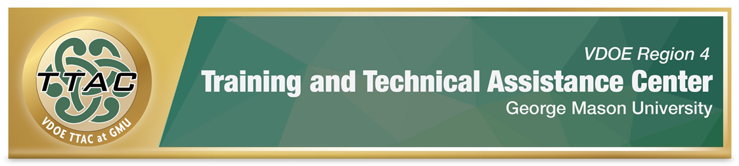 SDI Spotlight – Mathematics: Algebraic Concepts

SDI Spotlight Purpose: This spotlight was based on practices identified in VDOE’s Evidence Based Specially Designed Instruction in Mathematics, and focuses on specific strategies for algebraic concepts including the coordinate plane, using the Concrete-Representational-Abstract (CRA) method, an evidence-based practice. Brief videos demonstrating how to teach whole number operations with CRA and lesson plans when available are shared.

Considerations: Dr. Sarah Powell, Assistant Professor discusses important considerations when teaching students with difficulties in mathematics (8:22 mins): Considerations for teaching students with math difficulties video. To better understand the needs of students with mathematics disabilities, read: VDOE Students with Disabilities in Mathematics Frequently Asked Questions.

Explicit Instruction (HLP 16): Explicit instruction forms the foundation for delivering specially designed instruction. CEC created a checklist that walks teachers through phases of explicit instruction: CEC HLP 16 Checklist.

Proper Mathematics Vocabulary: It is essential to use and encourage student dialogue with proper mathematical vocabulary. VDOE identified important mathematics vocabulary: VDOE Word Wall Cards. Scaffolds like Frayer Models enhance students’ understanding of mathematics vocabulary.

Progress Monitoring: Monitoring student progress is an essential component of instruction. When students are not making meaningful progress, we gather data to analyze instructional practices and make necessary adjustments to improve student outcomes. Progress Monitoring Tools:
- National Center on Intensive Interventions Student Progress Monitoring Tool for Data Collection and Graphing
Learn: How to interpret progress monitoring data: Project Stair (4:29 mins.) and how to use error analysis in mathematics IRIS Center (2015) Page 7 Error Analysis for Mathematics.

Concrete-Representational Abstract (CRA) Method, an Evidence Based Practice (EBP)
Read about CRA & Visual Representations IRIS Center (2017) Page 5 Visual Representations.
- Learn about CRA: LD@School self-paced learning - Concrete-representational-abstract method.

Algebraic Concepts
Both Concrete-Representational-Abstract (CRA) methods for teaching Algebra and Meta-Cognitive Strategies are research-based strategies for students with disabilities.

Concrete-Representational-Abstract
Concrete-Representational & Abstract (CRA) Methods for teaching Algebra are research-based strategies for students with disabilities. CRA can be taught using Algeblocks and Algebra Tiles.

Algeblocks & Algebra Tiles
Project Stair created a website that introduces teachers to Algeblocks and how to use them. VDOE created Math Instructional Plans that incorporate Algeblocks.

Resource | Description
Project Stair: Solving Equations with Algeblocks Video | A video series demonstrates how teachers instruct with Algeblocks. The videos are brief.

Algebra Tiles
Resource | Description
NCETM Introduction to Algebra Tiles Video | NCETM introduces Algebra Tiles and shows teachers how Algebra Tiles help students in this (5:48 minute) video.

Virtual Manipulatives (free)
- Didax Virtual Manipulatives
- EquatIO Activities Database
- Kentucky Center for Mathematics
- Math Playground
- Math Learning Center
- National Library of Virtual Manipulatives
- Toy Theatre

The Coordinate Plane
There are many ways to teach students about coordinate planes. Many students with disabilities will struggle with this abstract concept, and it is important to build their understanding through concrete representations. Scaffolds such as graphic organizers enhance student understanding.

Concrete Representational Abstract Integrated – CRA-I Model
The CRA-I Model integrates concrete, representational, and abstract at the same time. CRA-I is especially helpful in upper-level math courses in Middle & High School.

Geoboard: Geoboards help us teach with the Concrete-Representational-Abstract Method.
- Math Learning Center Virtual Geoboard
- Toytheater Virtual Geoboard
- Pearson Guide – Geoboards and Slope

Skill | Video
Introduction to the Coordinate Plane | Project Stair Coordinate Plane Video
Coordinate Plane – Part 2 | Project Stair Coordinate Plane Part 2
Graphing Ordered Pairs from an Input Output Table | Project Stair Graphing Ordered Pairs from an Input Output Table
Rate of Change/Slope | Teaching Slope Concepts with Geoboards Video (8:54 minutes)  Multi-Sensory Slope Dude Video  Use with Geoboards & Movement  Cognitive Strategy Instruction:  VUX HOY – Vertical & Horizontal Lines Video (4:26 minutes)
Quadratic Expressions:  Project Stair has a series of videos showing teachers how to use concrete manipulatives to teach quadratic expressions and equations. | Project Stair Teaching Quadratic Expressions Playlist
Word Problems -Schema Based Instruction  Project Stair has a series of videos that demonstrate how teachers can implement Schema Based Instruction, an Evidence Based Practice (EBP) | Project Stair Schema Based Instruction Playlist
Differentiating Math Instruction during Whole Group Instruction | Project Stair: Differentiating Mathematics in Whole Group Instruction Video (6:14)

Additional Resources

Intensive Interventions and Lesson Plans The National Center on Intensive Intervention identified several strategies and interventions that enhance the skills of students with math difficulties in number system and counting, place value computation, basic facts, fractions as numbers, place value concepts, and computation of fractions.

The IRIS Center. (2017). High-quality mathematics instruction: What teachers should know. Retrieved from https://iris.peabody.vanderbilt.edu/module/math/

Learning Mathematics through Representations
“Learning Mathematics through Representations (LMR) is a research-based curriculum unit for the teaching and learning of integers and fractions in the elementary grades (26 lessons).

Henrico County, VA Mathematics Courses – Activities and links that are aligned to grade level SOL

Whilst GMU TTAC strives to adhere to the accepted guidelines and standards for accessibility and usability, it is not always possible to do so when linking to documents and sites outside of our site. We are continually seeking out solutions that will bring these other areas up to the same level of overall web accessibility. In the meantime, should you experience any difficulty in accessing the material, please do not hesitate to contact us at ttacnews@gmu.edu.
.

References

The IRIS Center. (2015). Intensive intervention (part 2): Collecting and analyzing data for data-based individualization. Retrieved from https://iris.peabody.vanderbilt.edu/module/dbi2/

The IRIS Center. (2017). High-quality mathematics instruction: What teachers should know. Retrieved from https://iris.peabody.vanderbilt.edu/module/math/

