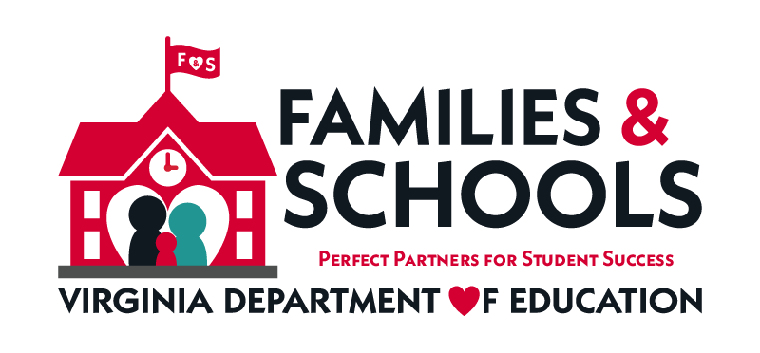

Family Engagement in Education Month
Governor Ralph S. Northam, Superintendent of Public Instruction
Dr. James F. Lane and the Virginia Department of Education recognize
November as Family Engagement Month in the
Commonwealth of Virginia.

The importance of parental engagement in schools is well documented. Over 30 years of research shows that one of the most effective ways to increase student achievement is for parents to be actively involved in the education of their children.

November is Family Engagement Month in Schools
The Virginia Department of Education is committed to improving parent and family involvement for all students including students with disabilities. We believe that family school collaboration is essential to student success.
Check out the following links for resources:

- Center for Family Involvement (VCU, Partnership for People with Disabilities)
- Department of Defense: Special Needs Parent Tool Kit – Birth to 18
- Guidance for Military Families with Students in Special Education
- National PTA Standards for Successful Family-School Partnerships
- Parent Education Advocacy Training Center (PEATC)
- Title I – Parent Involvement
- US Department of Education: Family and Community Engagement
- Virginia Family Special Education Connection
- Virginia PTA

Family Engagement Resources that Can Support the National PTA Standards for Family-School Partnerships
These standards offer a framework for how families, schools, and communities should work together to support student success.

PTA Standard 1- Welcoming All Families
- Center for Schools & Communities: Building. Strengthening. Transforming. How We Can Work Together

- Culturally Responsive Family Engagement Tips

- Education World: Does Your School’s Atmosphere Shout “Welcome?”(2005)

- Edutopia: Five-Minute Film Festival: Parent-Teacher Partnerships (2014)

- Engage Every Family - Five Simple Principles by Steven M Constantino (2020)

- Family Friendly Schools

- One Voice- Blog postings on Family Engagement

- Recorded Webinar- Stories from the Field: Successful Practice in Engaging Families During COVID-19

PTA Standard 2- Communicating Effectively
- Engage Every Family: Five Simple Principles by Steven M Constantino (2020)
- Recorded Webinar: The Power of Our Words

- Family Engagement: Collaborating with Families of Students with Disabilities (IRIS Center Module)

- Better Together: Powerful Family Partnerships (CONNECT Modules & Division for Early Childhood)

- Edutopia: Family Engagement: Resource Roundup

- Global Family Research Project

- I HAVE A QUESTION…What Parents and Caregivers Can Ask and Do to Help Children Thrive at School (A Parent Checklist) (U.S. Department of Education)

- TalkingPoints (Communicate with families in their home languages)

PTA Standard 3- Supporting Student Success
- Beyond the Bake Sale: The Essential Guide to Family-School Partnerships (Book)

- CBM (Curriculum Based Measure) at Home (Florida Center for Reading Research - Florida State University and Center on Teaching & Learning)

- Classroom Diversity: An Introduction to Student Differences (IRIS Center Module)

- Dual Language Learners with Disabilities: Supporting Young Children in the Classroom (IRIS Center Module)

- Edutopia: The Beginners’ Guide to Connecting Home and School (2014)

- Evidence-Based and Promising Practices to Support Continuity of Learning for Students With Disabilities (OSEP)

- Families in Schools- Building Partnerships for Student Success (Resources available in Spanish)

- Family Guide to at-Home Learning and Infographic (CEEDAR Center)

- How Family, School, and Community Engagement Can Improve Student Achievement and Influence School Reform (Nellie Mae Education Foundation)

- Joining Together to Create a Bold Vision for Next-Generation Family Engagement: Engaging Families to Transform Education (Oct. 23, 2018)

- National Center for Families Learning (NCFL)

- National PTA: Parent’s Guide to Student Success - Math & Reading Guides

- Parents: Supporting Learning During the COVID-19 Pandemic (IRIS Module)

- Positive Engagement• Positive Engagement (Relationship building with students and families) (VDOE Chronic Absenteeism Series- Module 5)

- Supporting Individuals with Autism through Uncertain Times (Autism Focused Intervention Resources & Modules, AFIRM) National Professional Development Center (NPDC) on ASD

- Supporting Students with Disabilities at School and Home: A Guide for Teachers to Support Families and Students

- Supporting Students with the Most Intensive Needs (Center for Parent Information)

- Understood: Working with your child’s teachers

- Universal Design for Learning (UDL): Creating a Learning Environment that Challenges and Engages All Students (IRIS Center) (2021)

PTA Standard 4- Speaking up for Every Child
- Aligning and Integrating Family Engagement in Positive Behavioral Interventions and Supports (PBIS) Concepts and Strategies for Families and Schools in Key Contexts

- Center for Family Involvement (VCU, Partnership for People with Disabilities)

- Gender Diversity & Model Policies for the Treatment of Transgender Students in Public Elementary and Secondary Schools (Virginia Department of Education, VDOE)

- National PTA Standards for Family-School Partnerships

- PACER Center: Champions for Children with Disabilities

- ParentAdvocates.org

- PEATC: Parent Educational Advocacy Training Center

PTA Standard 5- Sharing Power
- Communication is Not Engagement- Advancing Equity Through Family Efficacy (VDOE EDEquityVA Webinar)

- CONNECT Module 4: Family-Professional Partnerships (Early Childhood)

- Engage Every Family: Five Simple Principles by Steven M Constantino (2020)

- Joining Together to Create a Bold Vision for Next-Generation Family Engagement: Engaging Families to Transform Education (Oct. 23, 2018)

- National PTA Standards for Family-School Partnerships

- PTA: You are Key to Your Child’s Success

- Video: Promoting Equity in Education Through Family Engagement (Formed Families Forward)

- Videos: Critical Decision Points for Families of Children with Disabilities (Virginia Department of Education, VDOE)

PTA Standard 6- Collaborating with Community
- Cultural and Linguistic Differences: What Teachers Should Know (IRIS Center Module)

- Engage Every Family: Five Simple Principles by Steven M Constantino (2020)

- Inclusive Practices in Successful Schools: Virginia Inclusive Action Planning Guide Module

- National Association for Family, School, and Community Engagement

- Parent Engagement Toolkit (America’s Promise Alliance)

Compiled by the Virginia Department of Education’s Family Engagement Network (FEN)
Updated October 2021 - available on TTAC Online or
Virginia Family Special Education Connection

