****Dr. Anya Evmenova

Dr. Kelley Regan

Dr. Boris Gafurov

**George Mason University**

<https://wegowriting.com>

WEGO aims to promote an effective integration of a free and accessible **technology-based writing intervention package** including **technology tools** for students & **instructional resources & professional development** for teachers to improve the quality of **essay writing** across the curriculum for **students with and without high-incidence disabilities struggling with writing** in elementary and middle schools & alternative settings.

# TECHNOLOGY-BASED WRITING INTERVENTION PACKAGE

## **Components**

* 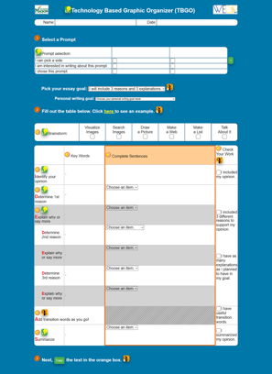Technology-based graphic organizers with built-in evidence-based strategies (e.g., mnemonic, self-regulated learning strategies)
* Universal Design for Learning (UDL) supports (e.g., audio comments, text hints, text-to- speech)
* 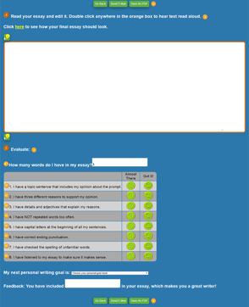Video models to introduce students to high- quality essay parts with video guides and remediation activities
* Educational games to learn and practice the components of the writing process (coming soon)
* AI-powered brainstorming support (coming soon)
* Instant data reports and data-driven decision- making materials for teachers
* Professional development modules for CEUs

## **Testimonials**

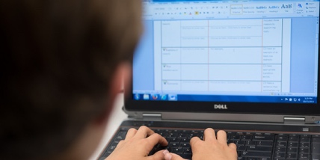*It has helped me become a better writer... I’ve been able to write better, ... not get lost, not get confused.* (student)

*I think all of the supports that come along with this tool are phenomenal*. (teacher)

This document was produced under U.S. Department of Education, Office of Special Education Programs **No. H327S120011, No. H327S180004,** as well as **No. H327R230014.** The views expressed herein do not necessarily represent the positions or policies of the Department of Education. No official endorsement by the U.S. Department of Education of any product, commodity, service or enterprise mentioned in this publication is intended or should be inferred.

# WEGO: Writing Efficiently with Graphic Organizers

## Selected References

Mergen, R. L., Evmenova, A. S., Regan, K., Gafurov, B., & Hutchison, A. (2024). Exploring persuasive writing outcomes using a technology-based graphic organizer for students served in an alternative special education program. *Behavior Disorders*. <https://doi.org/10.1177/01987429241290238>

Hutchison, A., Evmenova, A. S., Regan, K., & Gafurov, B. (2024). Click, see, do: Using digital scaffolding to support persuasive writing instruction for emerging bilingual learners. *Reading Teacher*, *77*(6), 810-824. <http://doi.org/10.1002/trtr.2310>

Regan, K., Evmenova, A. S., Mergen, R., Verbiest, C., Hutchison, A., Murnan, R., Field, S., & Gafurov B. (2023). Exploring the feasibility of virtual professional development to support teachers in making data-based decisions for improving student writing. *Learning Disabilities Research &*

*Practice*, *38*(1), 40-56. <https://doi.org/10.1111/ldrp.12301>

Day, J., Regan, K., Evmenova, A. S., Verbiest, C., Hutchison, A., & Gafurov, B. (2022). The resilience of students and teachers using a virtual writing intervention during COVID-19. *Reading & Writing Quarterly*, *39*(5), 390-412. <https://doi.org/10.1080/10573569.2022.2124562>

Brady, K. K., Evmenova, A. S., Regan, K., Ainsworth, M., & Gafurov, B. (2022). Using a technology- based graphic organizer instruction to improve the planning and persuasive paragraph writing of

students with complex intellectual profile. *Journal of Special Education*, *55*(4). 222-233. <https://doi.org/10.1177/00224669211008256>

Regan, K., Evmenova, A. S., Hutchison, A., Day, J., Stephens, M., Verbiest, C., & Gufarov, B. (2021). Steps for success: Making instructional decisions for students’ essay writing. *TEACHING Exceptional Children*, *54*(3), 202-212. <https://doi.org/10.1177/00400599211001085>

Evmenova, A. S., Regan, K., Ahn, S. Y., & Good, K. (2020). Teacher implementation of a technology- based intervention for writing. *Learning Disabilities: A Contemporary Journal*, *18*(1), 27-47. <https://www.ldw-ldcj.org/>

Boykin, A., Evmenova, A. S., Regan, K., & Mastropieri, M. (2019). The impact of a computer-based graphic organizer with embedded self-regulated learning strategies on the argumentative writing of students in inclusive cross-curricula settings. *Computers & Education*, *137*, 78-90. <https://doi.org/10.1016/j.compedu.2019.03.008>

Hughes, M., Regan, K., & Evmenova, A. S. (2019). A computer-based graphic organizer with embedded self-regulated learning strategies to support student writing. *Intervention in School and Clinic*, *55*(1), 13-22. <https://doi.org/10.1177/1053451219833026>

Regan, K., Evmenova, A. S., Good, K., Leggit, A, Ahn, S., Gafurov, G., & Mastropieri, M. (2018). Persuasive writing with mobile-based graphic organizers in inclusive classrooms across the curriculum. *Journal of Special Education Technology*, *33*(1), 3-14. <https://doi.org/10.1177/0162643417727292>

Evmenova, A. S., Regan, K., Boykin, A., Good, K., Hughes, M. D., MacVittie, N. P., Sacco, D., Ahn,

S. Y., & Chirinos, D. S. (2016). Emphasizing planning for essay writing with a computer-based graphic organizer. *Exceptional Children*, *82*(2), 170-191. <https://doi.org/10.1177/0014402915591697>