**Instructional Activity Resources for 7M-NSCE 1**

**Adding with Like Denominators with Shaded Pieces**

One-half plus one-half
modeled by using a rectangle that is half shaded plus another rectangle half shaded.  
A half shaded rectangle plus a half shaded rectangle equals how many shaded pieces in the rectangle?
Display the answer by shading the correct amount of pieces in the white rectangle.


two fourths plus one-fourth
modeled by using a rectangle divided into 4 pieces.
2 shaded pieces out of 4 total peices plus 1 shaded piece out of 4 total pieces should equal how many shaded pieces? 
Display the answer in the bottom rectangle by shading in the correct amount of pieces on the rectangle. 


**Adding with Like Denominators**

calculate four eighths plus three eighths:
modeled by using a rectangle that is divided into 8 pieces. 
The first rectangle is divided into 8 pieces and 4 are shaded. 
The second rectangle is also divided into 8 pieces and 3 of them are shaded.
display in the bottom rectangle how many pieces should be shaded out of the 8 total pieces. 

calculate one-third plus one-third: 
modeled by using a rectangle that is divided into 3 pieces. 
the first rectangle is divided into 3 pieces and 1 piece is shaded.
the second rectangle is also divided into 3 pieces and 1 is shaded. 
display in the bottom rectangle how many pieces should be shaded. 

**Instructional Activity Resources for 7M-NSCE 1**

**Adding with Like Denominators Without Shading**

calculate one-half plus one-half:
the first rectangle is divided into 2 pieces. the second rectangle is also divided into 2 pieces. 
identify what one-half plus one-half by shading in the correct amount of pieces on the rectangles. 
display the result in bottom rectangle that is divided into 2 blank peices. 

calculate two fourths plus one-fourth:
the first rectangle is divided into 4 pieces.
the second rectangle is also divided into 4 pieces. 

identify two-fourths plus one-fourth by shading in the correct amount of pieces in each rectangle. 

display the result in the bottom rectangle that is divided into 4 pieces. 

**Adding with Like Denominators**

calculate four eighths plus three eighths:
the first rectangle is divided into 8 pieces. The second rectangle is divided into 8 pieces. 

display the result in the bottom rectangle that is divided into 8 pieces. 

calculate one-third plus one-third:
the first rectangle is divided into 3 pieces.
the second rectangle is divided into 3 pieces. 
display the result in the bottom rectangle that is divided into 3 pieces. 

**Instructional Activity Resources for 7M-NSCE 3**

**RATIO PICTURE CARDS**

first picture:
What is the ratio of dog to cat in this picture? 
First row: dog, cat, dog
Second row: dog, dog, cat
Second picture:
What is the ratio of football to basketball in this picture?
First row: football, football, football
second row: basketball, football, football
third row: football, basketball, basketball 
Third picture: 
What is the ratio of shark to jellyfish in this picture?
first row: shark, jellyfish
second row: shark, shark 
fourth picture:
What is the ratio of the Nationals score to the Orioles score in the picture?
Modled by a chart that displays the Nationals with seven and Orioles with two. 



**RATIO PICTURES**

First picture: 
What is the ratio of candy bar to lolipop in the picture? 
The picture has 3 rows. 
First row: candy bar,candy bar
Second row: lolipop, lolipop. lolipop
Third row: candy bar, candy bar 
Second picture:
What is the ratio of stars to moons in the picture?
The picture displays stars and moons in 4 rows. 
First row: star, moon, star
Second row: star, star, star
Third row: star, star, star
Fourth row: star, moon, star 
Third picture: 
What is the ratio of heart to lightning bolt displayed in the picture? 
The picture displayes hearts and lightning bolts in 3 rows.
First row: heart, lightning bolt, heart 
Second row: lightning bolt, heart, lightning bolt, heart
Third row: heart, lightning bolt, heart
Fourth picture: 
What is the ratio of the Wizards score to the Lakers score?
The score is displayed in a chart that has Wizards wih a score of 78 and Lakers with a score of 112.



**Instructional Activity Resources for 7M-MG 1**

**Finding Area**

Determine the area of a given surface by **estimating** and then finding the number of square units needed to cover the surface. Use tiles or cheese crackers to find the area.

The picture displays 64 squares and 36 of those 64 squares are shaded. 

The student needs to find the area of the surface. 

there are 64 squares in the picture. 32 of the 64 sqaures are shaded. 
The student needs to count the shaded square tiles to find the area.


there are 64 squares in the picture.
27 of the 64 squares are shaded. 
The  student needs to count these shaded square tiles to find area.


**What's the Area?**

**Directions: The student determines the area using tiles, repeated addition, and/or multiplication.**

There are 4 rectangles
the left rectangle has a width of 4 inches and had a height of 3 inches.  
The top right rectangle has a width of 2 inches and a heigth of 3 inches. 
The bottom right rectangle has a width of 2 inchesand a height of 2 inches. 
The bottom rectangle has a width of 7 inches and a height of 1 inch. 


There are a total of 3 rectangles. 
The top rectangle has a width of 7 inches and a height of 3 inches. 
The left rectangle has a height of 6 inches and width of 2 inches. 
The bottom right rectangle has a height of 4 inches and width of 3 inches. 

**Instructional Activity Resources for 7M-MG 2**

**Shape Sort**

**Directions: Have students sort the shapes.**

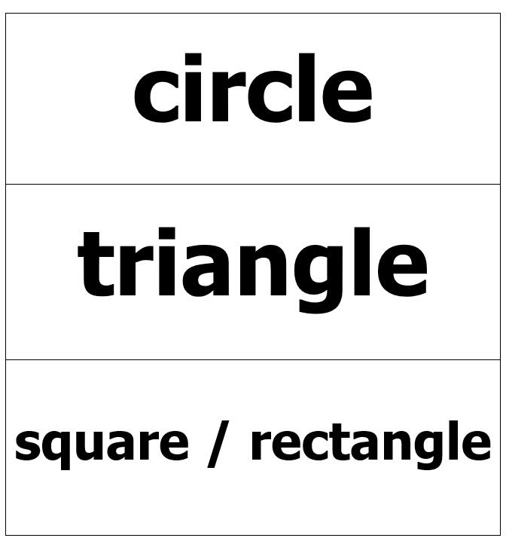

The picture is a rectangle divided into 4 rectangles. 
The upper left rectangle is a circle. The upper right rectangle is a triangle. The bottom left is rectangle. The bottom right rectangle is a rectangle. 

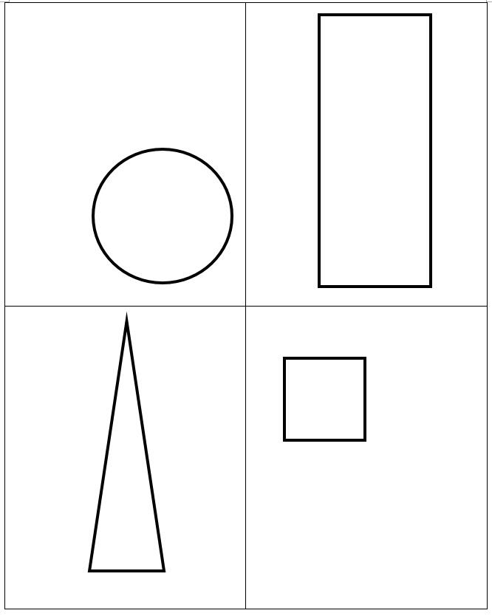

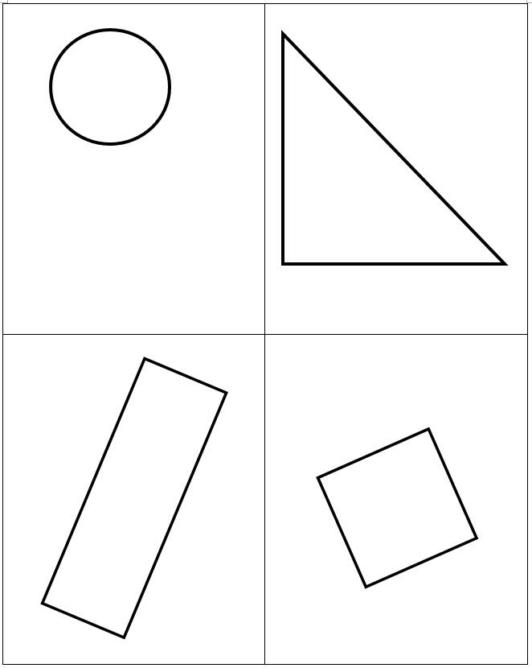

**Choosing Shapes: Have students select a specific shape from a group of shapes.**

There is rectangle divided into 6 rectangles. The upper left rectangle has a picture of a rectangle. The rectangle below it is a picure of a rectangle. The rectangle below it is picture below it is a circle. 
The upper right rectangle has a picture of a rectangle. The rectangle below it has a picure of a circle. The rectangle below it has a picture of a circle. 

A rectangle that has 6 shapes. 
The upper left shape is a triangle. The shape below it is an upside down triangle. The bottom left is a rectangle. The upper right shape is a triangle. The shape below it is a square and the bottom right shape is a square. 

allA picture of 6 shapes. 
The upper left is a picture of a triangle. The one below is a picture a parallelogram. The bottom left has a picture of a trapazoid. The upper right is a picture of a triangle. The one below it is a picture of a parallelogram. And the bottom right is a picture of a trapazoid. 

There are 6 shapes displayed. 
The upper left is a picture of a hexagon. Below the hexagon there is a picture of a pentagon. The bottom left is a picture of a hexagon. The upper right is a picture of a pentagon. Below the pentagon there is a picture of a pentagon. The bottom right is a picture of a trapazoid. 


**Instructional Activity Resources for 7M-PSPFA 1**

**Possible or Impossible?**

First row: An ant will eat my umbrella.
Second row: The Earth will stop spinning at 5 p.m. tomorrow. 
Third row: Your teacher will be at school tomorrow. 
Fourth row: You will turn into a fish. 
Fifth row: If I roll dice, I will roll an odd number. 
sixth row: When I toss a coin it will land on tails. 
seventh row: It will be sunny tomorrow. 
Eighth row: You will see a shark swimming on your way home from school. 
Last row: You will celebrate your 30th birthday tomorrow. 


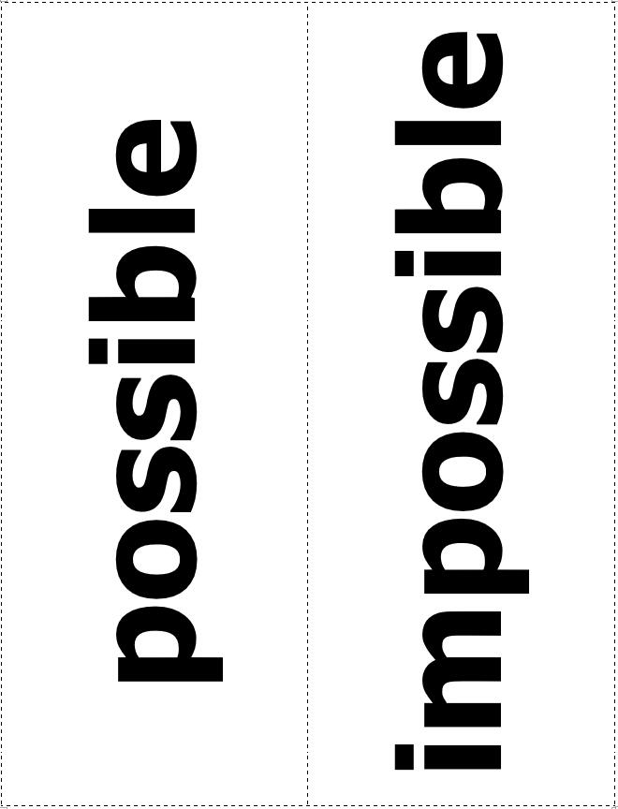

**Instructional Activity Resources for** **7M-PSPFA 2**

**Building the Commutative Property**

**Directions: Give the student the first part of an expression. Give them two choices to choose from to complete the expression to show the commutative property.**

**Set 1**

Set 1 is displayed in 3 boxes.
Top box says: 3 plus 4 equals
The middle box says: 4 plus 3
The bottom box says: 2 plus 6

**Set 2**

Set two is displayed in 3 boxes. 
The top box says  two times seven equals
The middle box says  three times four
The bottom box says seven times two 

**Set 3**

Set 3 is displayed in 3 boxes. 
Top box says five plus six equals
Middle box says ten plus one
Bottom box says six plus five 

**Set 4**

Set four is displayed in 3 boxes. 
The top box says two times six equals 
The middle box says six times two
The bottom box says three times four 

**Set 5**

Set five is displayed in three boxes. 
Top box says five black filled dot  2 equals
The middle box says five black filled dot two
The bottom box says two black filled dot five 

**Instructional Activity Resources for 7M-PSPFA 3**

**These cards can be used for comparing fractions to fractions.**

**There are 4 cards. 
The upper right card is a picture of a rectangle that is divided into two rectangles and one of the rectangles is shaded in. The upper left card displays the number one-half. 
The bottom left card is a picture of a sqaure that is divided into 4 squares and one sqaure is shaded. The bottom left card displays the number one-fourth. **

There are 6 cards.
The upper right card has a picture of a square that is divided into four sqaures and three sqaures are shaded. The upper left card has the fraction three-fourth displayed. 
The middle card has a picture of a rectangle that is divided into five rectangles and one rectangle is shaded. The card next to it has the fraction one-fifth displayed. 
The bottom left card has a picture of a rectangle that is divided into five rectangles and two rectangles are shaded. The Bottom right card has the fraction two-fifths displayed.  

There are 6 cards. 
The upper left card has a picture of a rectangle that is divided into five rectangles and three out of the five rectangles are shaded. The upper right card displays the fraction three-fifths. 
The left middle card has a picture of a rectangle that is divided into 5 rectangles. Four of the five rectangles are shaded. The right middle card displays the fraction four-fifths. The bottom left card has a picture of a rectangle that is divided into eight rectangles. One of the eight rectangles is shaded. The bottom right rectangle displays the fraction one-eighth. 

There are 6 cards. 
The upper left card has a picture of a rectangle that is divided into eight rectangles. two of the eight rectangles are shaded in. The upper right rectangle displays the fraction two-eighths. The middle left card has a picture of a rectangle that is divided into eight rectangles. Three of the eight rectangles is shaded in. The middle right card displays the fraction three-eighths. The bottom left card has a picture of a rectangle that is divided into eight rectangles. Four of the eight rectangles is shaded in. The bottom right card displays the fraction four-eighths. 

There are six cards
The upper left card has a picture of a rectangle that is divided into eight other rectangles,five of the eight rectangles are shaded in. The upper right card displays the fraction five-eighths. The middle left card has a picture of a rectangle that is divided into eight rectangles and six of the eight rectangles are shaded in. The middle right card displays the fraction six-eighths. The lower left card has a picture of a rectangle that is divided into eight rectangles. Seven of the eight rectangles are shaded in. The lower right card displays the fraction seven-eighths. 

**These cards can be used for comparing fractions to decimals.**

There are six cards. 
The upper left card has a picture of a rectangle that is divided into ten rectangles. Five of the ten rectangles are shaded in. The upper right card displays the decimal 0.5. The middle left card has a picture of a square that is divided into 100 smaller squares. 25 of the 100 squares are shaded in. The middle right card displays the decimal 0.25. The lower left card has a picture of a square that is divided into 100 smaller squares. 75 of the 100 squares are shaded in. The bottom right square displays the decimal 0.75.

There are 6 cards
The upper left card has a picture of a rectangle that is divided into 10 smaller rectangles. 2 of the 10 rectangles are shaded in. The upper right card displays the decimal 0.2.
The middle left card has a picture of a rectangle that is divided into 10 smaller rectangles. 3 of the 10 rectangles are shaded in. The middle right card displays the decimal 0.3. The lower left card has a picture of a rectangle that is divided into 10 smaller rectangles. 4 of the 10 rectangles are shaded in. The lower right card displays the decimal 0.4. 

There are 6 cards.
The upper right card has a picture of a rectangle that is divided into 10 smaller rectangles. 5 of the 10 rectangles are shade in. The upper left card displays the decimal 0.5
The middle right card has a picture of rectangle that is divided into 10 smaller rectangles. 6 of the 10 rectangles are shaded in. The middle right card displays the decimal 0.6
The bottom left has a picture of a rectangle that is divided into 10 smaller rectangles. 7 of the 10 rectangles are shaded in. The bottom right rectangle displays the decimal 0.7


There are 4 cards.
The upper left card has a picture of a rectangle that is divided into 10 smaller rectangles. 8 of the 10 rectangles are shaded in. The upper right card displays the decimal 0.8
The bottom left card has a picture of rectangle that is divided into 10 smaller rectangles. 9 of the 10 rectangles are shaded in. The bottom right card displays the decimal 0.9 
